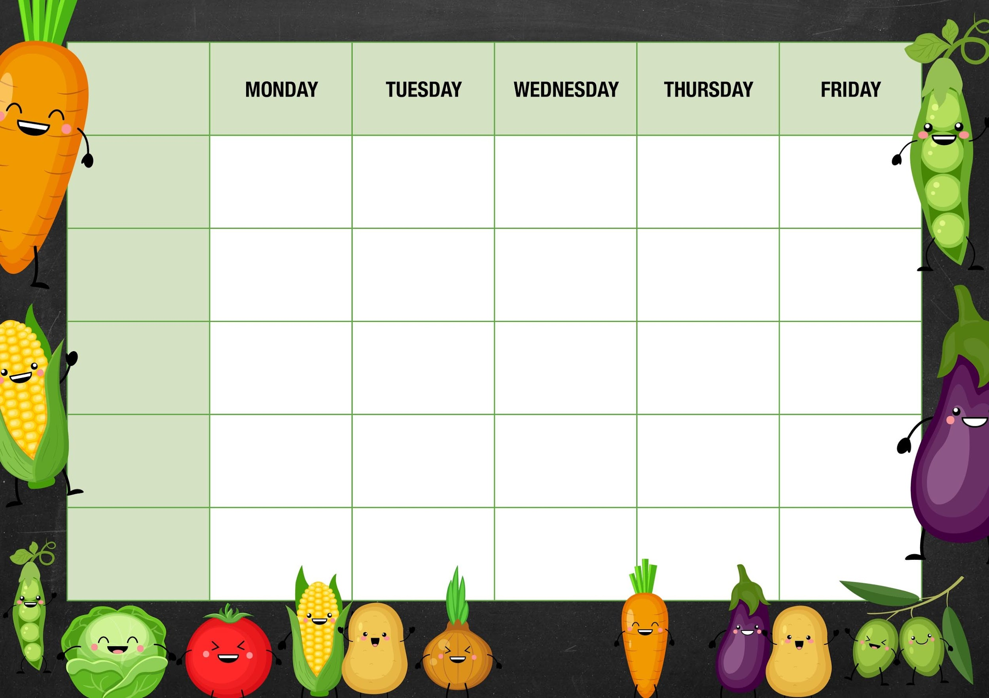MM

*Sweet Potato Balti Curry served with Dinky Potatoes*

*Lasagna served with Garlic Bread*

***Salad and Deli Bar***

***Week 3***

*Chicken Tikka Masala Curry with Basmati Rice and Naan Bread*

***Vegetable***

***Jacket Potato Choice***

*Jelly and Fruit*

*Marble cake and Custard*

*Jam Button Biscuit*

*Cheese and Onion Roll served with Chips*

*Vegetable Chili Con Carne served with Basmati Rice*

*Quorn Goujons served with Potato Croquette’s and Baked Beans*

***Garden Peas***

*Choice of Baked Beans or Cheese*

*Vegetable Lasagna served with Garlic Bread*

*Sausage in Gravy served with Creamy Mash*

***Meat Free Monday***

*Cheese Whirls served with Dinky Potatoes and Baked Beans*

*Cheese and Crackers*

*Muller light Yoghurt and Melon*

***Mixed Vegetables***

*Choice of Baked Beans Tuna or Cheese*

***Fishy Friday***

*Traditional Fish Fillet served with Chips and Tomato sauce*

***Cut Green Beans***

*Choice of Baked Beans or Cheese*

***Cauliflower Florets***

*Choice of Baked Beans, Cheese or Vegetable Chili*

***Diced Carrots***

*Choice of Baked Beans, Tuna, Cheese or Chicken Tikka*

*Deli Counter and a selection of fruit*

*Freshly Baked Bread*

*Deli Counter and a selection of fruit*

*Freshly Baked Bread*

*Deli Counter and a selection of fruit*

*Freshly Baked Bread*

*Deli Counter and a selection of fruit*

*Freshly Baked Bread*

*Deli Counter and a selection of fruit*

*Freshly Baked Bread*

***Mains***

***Vegetarian***

***Option***

***Dessert***